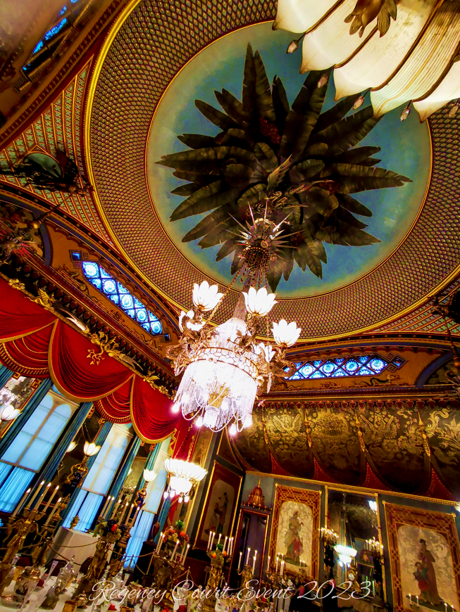
The Royal Pavilion Grand Regency Ball
16th January 2027

Evening Dress Guide for Guests

Guests may dress in whatever gender will ensure they have a delightful evening. Materials are not important, silhouette and enjoyment are.

Gentlemen

Formal Regency Evening Dress

- White frilled Shirt and Cravat.
- White, black or cream stockings.
- White, Black or Cream breeches or in a material that matches your coat.
- Waistcoat in any Regency style.
- Tailcoat in the Regency Style, either closing or ‘Court style’
- Black leather pumps or buckled shoes. Exemptions will be made on medical grounds.
- Hair in a Regency Style or if long enough, tied with a black ribbon.
- White leather gloves.
- Bicorn hats are preferable for evening, but top hats may be worn.
- Canes to be left in the cloakroom (unless required for mobility)
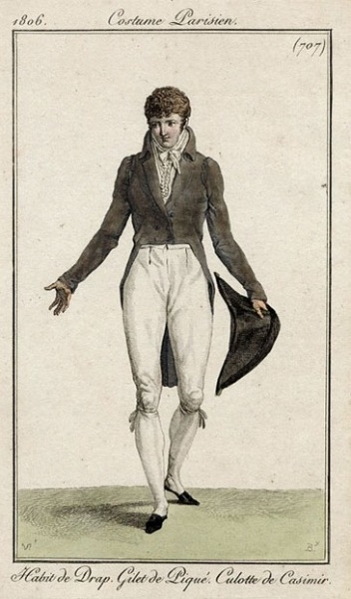
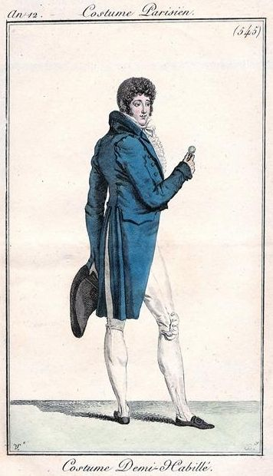
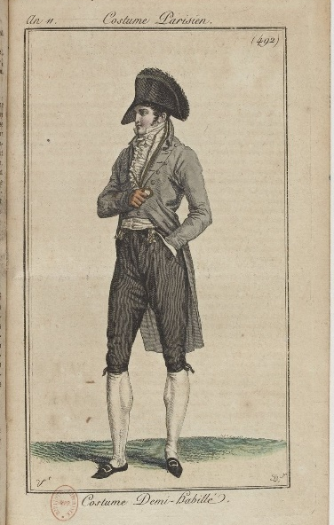
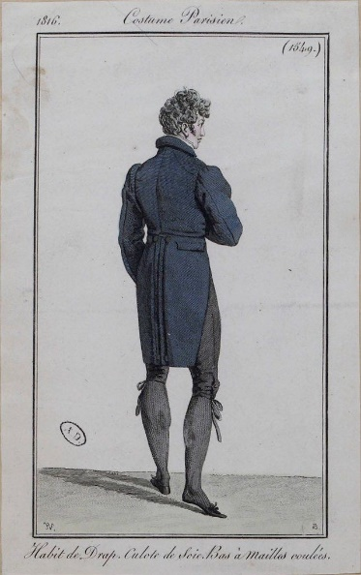

Military Uniforms
- Any Military Dress Uniform from Great Britain and her allies 1800-1815.
- White breeches or those set out in the Uniform Regulations.
- White frilled shirt and Cravat (unless black is stated)
- Black leather pumps or Buckled shoes. NO BOOTS.
- White or black silk stockings as per regulation.
- White leather gloves.
- Hair to be curled and powdered with ornamental wig bag at back of neck.
- NO SWORDS.
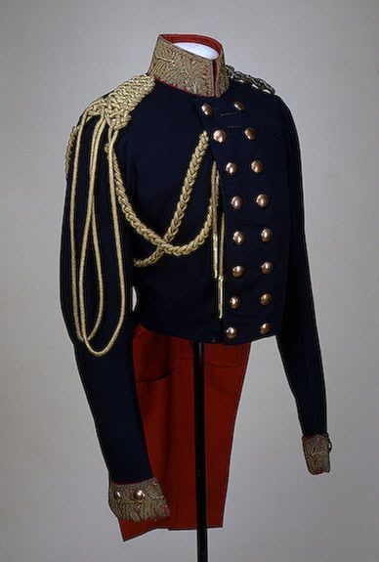
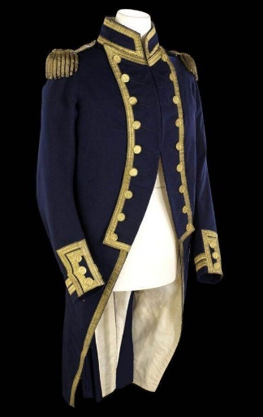
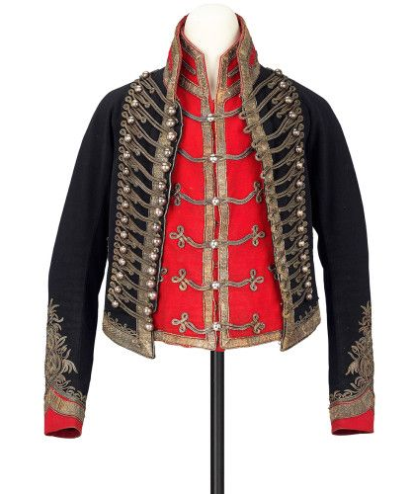
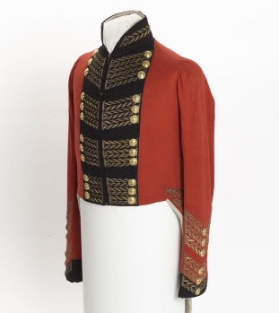
- NO FRENCH UNIFORM WILL BE PERMITTED!

Court Dress
This is the most formal of Men’s clothing and as such has various rules and stipulations.
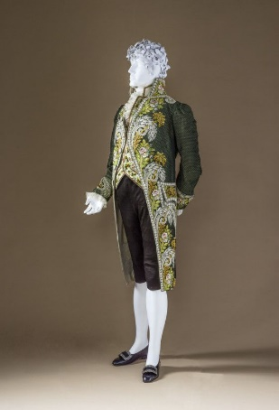
- White shirt and Cravat/stock.
- White or Black breeches or matching the coat.
- Pointed bottom waistcoat either with embroidery, figured or plain.
- Lace at cuffs and shirt frill.
- Curled and powdered hair or Court Wig with bag (please ask if unsure)
- Ornamental wig bag at back of collar if not wearing a wig.
- Bicorn hat (mainly to hold)
- White leather gloves.
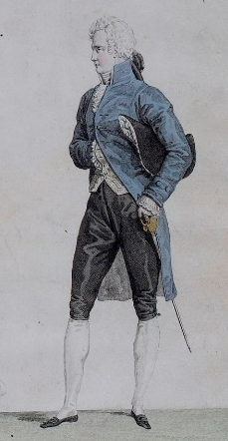
- Buckled Shoes.
- White silk stockings.
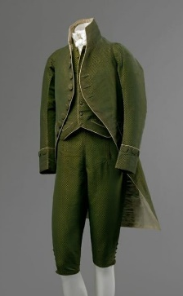
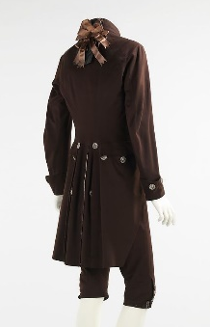
- Habit style court coat in wool, silk, velvet with or without embroidery with self-covered, cutsteel, embroidered or jeweled buttons. NO 18th CENTURY COURT SUITS.

Ladies

Formal Regency Evening Dress

- Empire line dress, this may have a train.
- Hair should follow the styles seen in the Regency which allows for; hairpieces, Regency style wigs and head wraps/turbans.
- White or cream stockings
- Dancing pumps or similar flat shoes.
- Makeup to follow the ideals of the period, so light and natural.
- Tiaras are absolutely encouraged.
- Feathers should follow the Royal Navy theme and be white, blue or yellow or all of the above. Black feathers are only worn in mourning and if you wish to honour a loved one, you may.
- White, cream, yellow or black evening gloves.
- English Regency Court Dress, if you wish to accept the challenge (please ask for details).
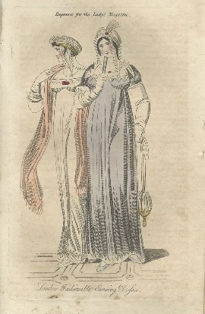
- NO FRENCH COURT DRESS.
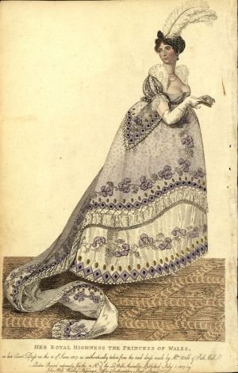
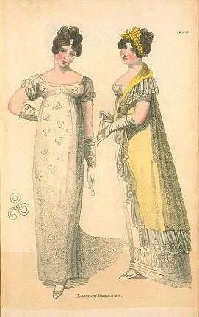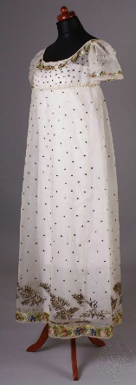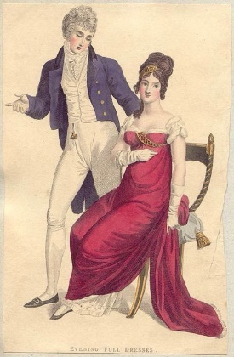
National/Traditional Cultural Dress
Many nations have their own cultural form of dress. If you are of a country’s native background and wish to attend dressed as such then that is perfectly acceptable, as long as the style of dress is that of 1800-1818.

If any Guests have any questions regarding appropriate attire please direct your questions via email to
info.pinsenttailoring@gmail.com

