Brighton & Hove Museums: Risk Assessment Form
Assessor(s): | Su Hepburn | Date: | January 2026
Task / Activity: | Organised Community Group Visits
Workplace / Site: | Brighton & Hove Museums, Preston Manor, Hove Museum,
Review Date: | May 2026
Persons affected by Task / Activity: | Staff and visitors
Other Vulnerable Persons affected by Task / Activity: | Protected characteristics staff and visitors
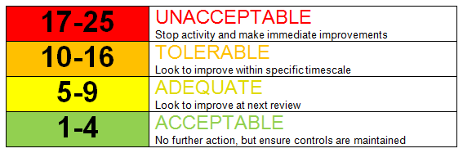
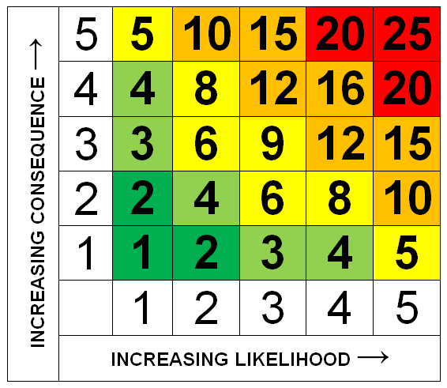

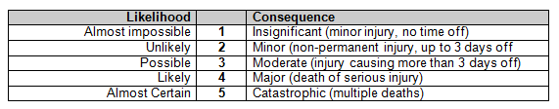

Potential Hazards |  | Initial Assessment of Risk |  |  | Control Measure Applied | Assessment of Residual Risks
 |  | Likelihood | Severity | Risk |  | Likelihood | Severity | Risk
1 | Trips or falls due to equipment or leads trailing | 3 | 2 | 4 | Ensure leads are secure where appropriate  Verbal instructions given by museum staff | 1 | 2 | 2
2 | Failure to exit room in event of fire or emergency | 2 | 3 | 6 | Clear signage of all fire exits  Fire exit refreshers with staff  FOH (front of house) team will ensure building is evacuated  Group leader asked when booking if anyone in their group will need extra assistance | 1 | 2 | 2
3 | Reckless, careless or unruly behaviour leading to injury to self or others | 2 | 1 | 2 | Groups supervised by Museum Educator  Clear instructions given on expected behaviour (Be Mindful) | 1 | 2 | 2
4 | Safeguarding | 2 | 3 | 6 | CYP(Children & young people) accompanied by Group Leader  FOH team identifiable by photo ID lanyard badge  Museum Educator identifiable photo ID lanyard badge  Museum Educator/FOH completed Safeguarding training  CYP kept together in sight of Museum Educator/Group Leader  Lost child / guardian procedures are in place  Sessions take place in public areas of the museum | 1 | 2 | 2
5 | Movement through buildings | 2 | 3 | 6 | Verbal instructions given  Narrow areas - circulate in single file  Steep staircase - strategic placing of adult supervisors, use handrail and lift any long clothing from the floor. Museum Educator to lead the way when with the group.  Clear marking of low ceilings | 1 | 2 | 2
6 | Adequate ventilation in teaching rooms | 2 | 2 | 4 | Open windows where possible.  Open doors where possible.  Use fan provided when rooms hot and stuffy  Ask group to remove coats and jumpers at beginning of sessions in summer  Plan sessions to reduce fainting after travel – e.g. sitting down in the beginning | 1 | 2 | 2
7 | Handling museum objects | 2 | 2 | 4 | Verbal instructions to be mindful – of themselves, their bags and other visitors.  Bags to be worn on the front of body in the Royal Pavilion  Clear instructions when handling objects.  Museum Educator position objects safely in the education room and make sure door is locked when not in use  Pack away objects immediately and carefully after the session | 1 | 2 | 2
8 | Electric heaters | 2 | 2 | 4 | To be placed away from groups.  Verbal instruction not to touch | 1 | 2 | 2
9 | Art materials – scissors, glue, paint, crayons etc | 3 | 3 | 9 | All materials from educational suppliers intended for use by children  Ensure appropriate materials used for age group  Verbal instruction on appropriate use of materials  Museum Educator supervision | 2 | 2 | 4
10 | Applicable to Catching the Sun session  Using equipment that could cause injury during workshops or after (accidental and self-harm).  Darkroom chemicals  Cyanotype chemicals  UV light box  Glass plates | 2 | 2 | 4 | Museum staff to demonstrate safe use with clear instructions  Photography chemicals to be handled by Museum Educator only  COSSH guidance followed and can be found in session folder  Goggles and gloves supplied for participants taking part  Glass plates to be carried with both hands only when clipped safely shut. Keep away from edge of table  List of materials available in case of any allergies | 2 | 2 | 4
11 | Lunchrooms | 3 | 3 | 9 | Group supervision by Group Leader  FoH are aware that groups are using the lunchroom.  Hand washing or anti-bacterial gel is available  Rooms are cleaned regularly | 2 | 2 | 4
12 | Access |  |  |  | Speak to group leader before visit about any accommodations or adjustments we can make to the sessions  Free entry for group leader to make pre visit risk assessment  General access information for each site on website

Additional Control Measures (if applicable) |  | Additional Comments and Observations
Circulation of Risk Assessment:
üEmployee(s) □ Client(s) □ Other occupiers of Premises □ Contractor(s) ü□ Visitor(s) □ Others:…………………………
Signed by Assessor(s): | Su Hepburn |  | Date: | January 2026

