Brighton & Hove Museums Shadow Trustee Recruitment

Are you passionate about Brighton & Hove?

Are you in your early career looking to break into or deepen your connection to the museum sector?

Do you want to use your experiences, skills and enthusiasm to help run Brighton & Hove’s Museums?

Then think about becoming a shadow trustee!

Brighton & Hove Museums are looking for two shadow trustees to join the organisation’s trust which is responsible for governing iconic Brighton institutions, including the Royal Pavilion and Brighton Museum & Art Gallery.

These positions have been designed to support those in their early career to develop their skills, confidence and governance experience to further their career development and consider trusteeships in the future.

We will provide you with a detailed introduction into the running of a collection of leading regional museums, enable you to explore how a board of trustees is run, and provide a mentor to support your wider development.

We are interested in those with a real commitment and passion for the museum sector. This position is voluntary with reasonable travel expenses reimbursed. As a shadow trustee, you will take full part in discussions but will not have any voting rights or legal responsibilities of a full trustee.

Brighton and Hove Museums are run by an independent charitable trust, the Royal Pavilion and Museums Trust, which is governed by a board of trustees https://brightonmuseums.org.uk/about-us/the-royal-pavilion-museums-trust/trustees/.

We are excited about our future ahead and want our decision making to reflect the people and voices we serve.

Want to find out more about what a young trustee does? https://youngtrusteesmovement.org/benefits

Welcome!

Thank you for your interest in joining the Board of Trustees of Brighton & Hove Museums (the Trust).

Firstly, a bit about us: the Trust came into being on 1 October 2020. We inherited from Brighton & Hove City Council responsibility for running five iconic destinations: The Royal Pavilion and Gardens, Brighton Museum & Art Gallery, Hove Museum of Creativity, Booth Museum of Natural History and Preston Manor and Gardens. We also manage the museum collections of Brighton & Hove and have a major digital presence – check out ourhttps://brightonmuseums.org.uk/.

We have about 150 staff who diligently look after our buildings, curate our collections and welcome visitors from across the globe. We have a great leadership team who manage these teams and buildings on a day-to- day basis and plan for their future success.

The role of the board of trustees is to oversee and monitor the successful running of the trust and support the leadership team in their work.
This is a major opportunity to be involved in shaping the vision for Brighton & Hove Museums, to be associated with one of the UK’s most iconic heritage sites as well as Brighton’s extraordinary portfolio of museums and their collections, and to contribute to positioning Brighton and Hove as a world class cultural centre.
Brighton has a history of doing things differently. We gladly follow its lead. If you’re keen to work with us, please get in touch.

Michael Bedingfield Chair of Trustees

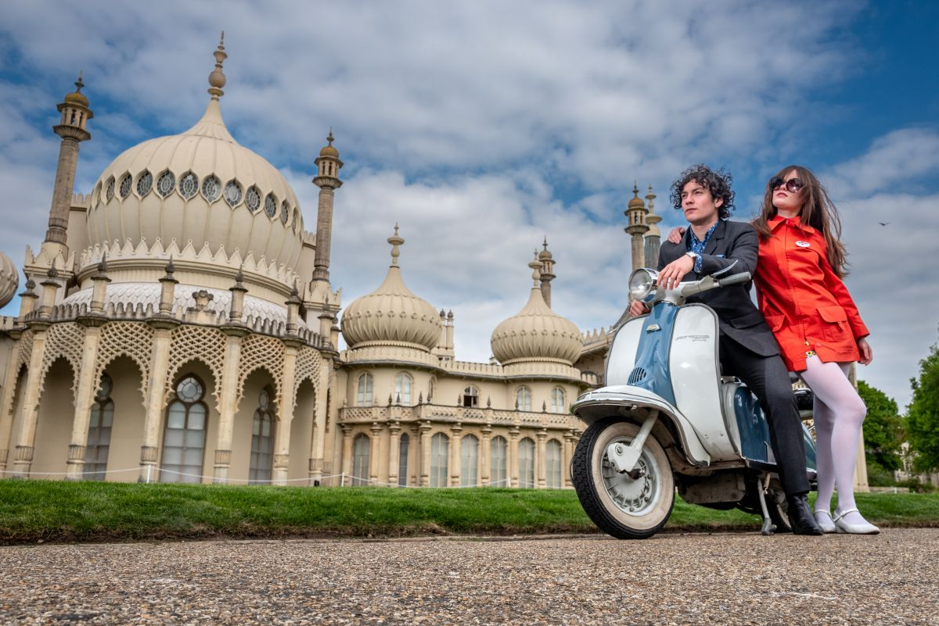

Brighton & Hove Museums

Brighton & Hove is a centre of creativity, freedom and belonging. The city is one of the most famous UK seaside resorts, unrivalled for its distinctive architecture, artistic innovation and commitment to social inclusion.
The buildings, collections and staff that make up the Trust are a fundamental part of Brighton & Hove’s identity and offering to the city. Our museums and collections have an international and national reputation and historical importance, and are treasured by visitors to the region as well as local communities:
- The Royal Pavilion and Garden welcomes visitors from around the world. Built as a royal palace in the late 18th and early 19th centuries, it is one of the most iconic buildings in the UK
- Brighton Museum & Art Gallery opened on its current site in 1902. Its eclectic nationally important collections include World Art, street fashion and design, as well as telling the story of Brighton and hosting temporary exhibitions
- The Booth Museum of Natural History, built in 1874, is one of the largest natural history museums in the UK, with collections of international scientific significance
- Hove Museum of Creativity, dating from 1873, has developed a reputation for family activities and exhibitions, as well as adult learning
- Preston Manor and Gardens was originally built in about 1600. The Manor is known for its formal and informal creative learning activities. It is reputedly the most haunted house in Sussex!
The Trust receives regular funding from Arts Council England as well as important financial support from Brighton & Hove City Council (BHCC). However, most of our income comes from ticket sales and commercial activity.

Vision and mission and future priorities

We are a world-renowned home for the curious, creative and progressive.

Many influences meet here – royal and rebel, dandy and dreamer, artist and activist – to form a collection of dynamic destinations that are greater than the sum of their parts and reflects Brighton’s unique identity.
We achieve this because we are:
- continually surprising people, including ourselves
- loved by locals and treasured by the world
- inspiring, and inspired by, the community around us
- sparking curiosity, starting conversations and sharing stories
- championing progress, diversity and sustainability

We want to contribute fully to Brighton & Hove being a major tourist destination and bring real value to the lives of everyone who lives in Brighton & Hove whatever their circumstances.

To deliver on these aims we recognise we need a board of trustees that are diverse, up for change and that reflect the population of Brighton & Hove.

We are putting in place a series of new initiatives that make maximum use of our sites and resources and make sure they stay relevant.
More information about the Trust, its sites, projects and plans can be found on the website
http://brightonmuseums.org.uk/

The Role

‘An amazing way to connect with a fantastic range of museums while broadening my experience.’ (Shadow trustee)

The Trust is looking for two Shadow Trustees to bring strength, experience and diverse perspectives to the Board. Shadow Trustees are expected to:

- Be an active advocate and champion for the Trust and its activities
- Contribute actively to board meetings, offering perspectives and views, and questioning managers
- Exercise reasonable care and skill, using personal skills and experience to help the Board of Trustees in collaboration with staff and stakeholders reach sound decisions
- Ensure that the Trust pursues its objects as defined within its governing document
- Gain an understanding of sound financial management of the resources of the Trust
- Gain an understanding of the terms of the contract with Brighton & Hove City Council, and that the requirements of other stakeholders are met

What are we looking for: “We have really valued having our shadow trustees. They bring a different perspective to our conversations and help us think about all our actual and potential audiences”. Hedley Swain, CEO

We’re looking for people who:

    - Are passionate about Brighton & Hove
    - Are in the early part of their career
    - Have an understanding of and commitment to the vision for the Trust
    - Are highly motivated to engage with heritage, museums, learning, gardens and conservation and their social role and purpose
    - Are confident team players, influencing and challenging the opinions and expertise of fellow trustees
- Are committed to equal opportunities and diversity and to contributing to a diverse and inclusive workforce and Trustee body
    - Can commit to a consistent level of involvement and time commitment during their term of office

What can we offer?

“A shadow trusteeship is a really valuable thing to put on your CV. It can help create connections with other really dedicated, excellent board members, who can then flag up opportunities to you.” Shadow Trustee

- The chance to help shape the future of Brighton & Hove Museums
- An invitation to immerse yourself in the heart of Brighton’s cultural sector
- The opportunity to join a network of leaders in the museum and heritage sector
- Validation for the knowledge that you have and building your confidence in applying for a trustee role in the future

Time Commitment, term of service, and remuneration

New trustees will be given a full induction which will include orientation days, the opportunity to meet with senior staff and a briefing on the responsibilities and duties of trustees. Support and mentoring will be provided including a ‘buddy’ system of support from an existing trustee.

- The Board meets four times a year, normally for about 2-3 hours in person on a weekday afternoon in central Brighton & Hove
- In advance of the board meeting, take part in an online briefing session with the ‘board buddy’
- In addition, trustees will be invited to visit the Trust offices and museum sites and attend a range of events across the Trust’s five museums during both daytimes and evenings
- Trustees will use their own specialist skills, experience and networks to support Trustee committees and staff / trustee working groups as appropriate

Length of service: the term of service will be two years.
This position is not remunerated but reasonable out of pocket expenses (including travel costs) will be reimbursed.

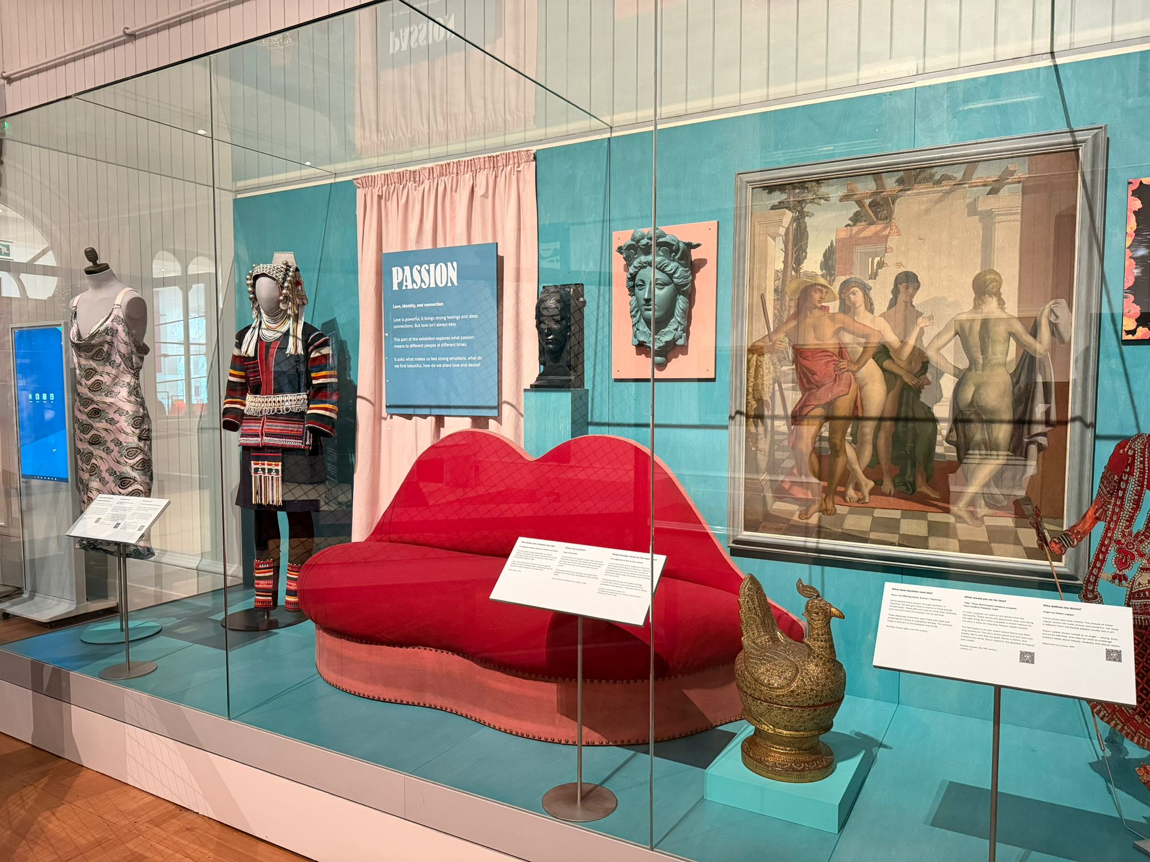

Recruitment process and indicative timetable

We hope you are interested in joining the Trust and using your skills and experience to realise our ambitions.

If you would like to speak to someone before making an application including the current shadow trustees, please contact Melanie Boardman (see below for contact details).

To apply, please send us:

- A personal statement explaining why you are interested in becoming a shadow trustee and what skills and experience you would bring. Please keep this to a maximum of 500 words or a video clip of maximum, 2 minutes
- Your CV, including at least two referees (references will only be contacted with prior permission and only if an applicant is offered a post on the board)
- A completed Application Pack
- A completed Equalities Form

Applications should be sent to Melanie Boardman, Executive Team Manager melanie.boardman@rpmt.org.uk

The closing date for applications is midnight Friday 28 November 2025.

Interviews will be held on Friday 9 January 2026 in Brighton Museum & Art Gallery.

Successful applicants will be invited to attend the board meeting on Wednesday 4 February 2026.

.

