Brighton & Hove Museums: Risk Assessment Form
Assessor(s): | Barnaby Salton | Date: | September 2023
Task / Activity: | Organised Group Visit
Workplace / Site: | Brighton & Hove Museums
Review Date: | Aug 2024
Persons affected by Task / Activity: | Staff and visitors
Other Vulnerable Persons affected by Task / Activity: | Protected characteristics staff and visitors
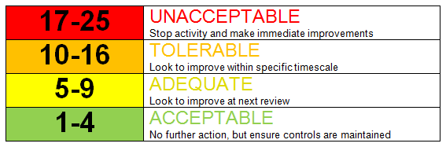
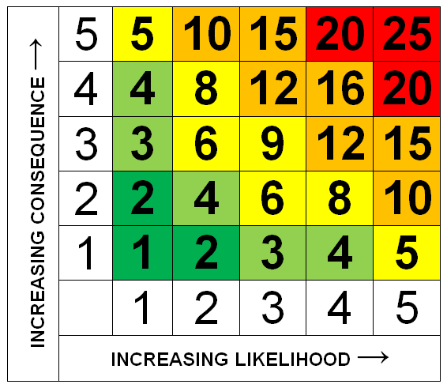

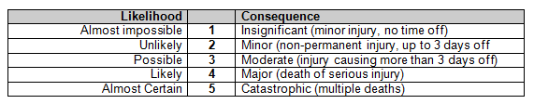

Potential Hazards |  | Initial Assessment of Risk |  |  | Control Measure Applied | Assessment of Residual Risks
 |  | Likelihood | Severity | Risk |  | Likelihood | Severity | Risk
1 | Trips or falls due to equipment or leads trailing | 2 | 2 | 4 | Ensure leads are secure where appropriate  Verbal instructions given by museum staff | 1 | 2 | 2
2 | Failure to exit room in event of fire or emergency | 2 | 3 | 6 | Clear signage of all fire exits  Fire exit refreshers with staff  FOH team will ensure building is evacuated  Teachers asked when booking if anyone in their group will need extra assistance | 1 | 2 | 2
3 | Reckless, careless or unruly behaviour leading to injury to self or others | 2 | 1 | 2 | Groups supervised by Learning Assistant / Guides  Clear instructions given on expected behaviour (Be Mindful) | 1 | 2 | 2
4 | Safeguarding | 2 | 3 | 6 | CYP accompanied by Group Leader  FOH team identifiable by uniform and photo ID lanyard badge  Learning Assistant / Guide identifiable photo ID lanyard badge  Costumed staff to carry staff ID with them in pockets so it is to hand if needed  Learning Assistant / Guide /FOH training on Safeguarding and conformation of reading SG Policy  Children kept together in sight of Learning Assistant / Guide or Class/Group Leader  Lost child / guardian procedures are in place  Sessions take place in public areas of the museum  Public signs are in place asking visitors to not photograph school children | 1 | 2 | 2
5 | Movement through buildings | 2 | 3 | 6 | Verbal instructions given  Narrow areas - circulate in single file  Steep staircase - strategic placing of adult supervisors, use handrail and lift any long clothing from the floor. Learning Assistant / Guide to lead the way when with the group.  Clear marking of low ceilings | 1 | 2 | 2
6 | Adequate ventilation in teaching rooms | 2 | 2 | 4 | Open windows where possible.  Open doors where possible.  Use fan provided when rooms hot and stuffy  Ask children to remove coats and jumpers at beginning of session in summer  Plan sessions to reduce fainting after travel – e.g. sitting down in the beginning | 1 | 2 | 2
7 | Handling museum objects | 2 | 2 | 4 | Verbal instructions to be mindful – of themselves, their bags and other visitors.  Bags to be worn on the front of body in the Royal Pavilion  Clear instructions when handling objects. Valuable objects handled over carpet and while sitting | 1 | 2 | 2
8 | Handling Animal remain specimens |  |  |  | Advice given for everyone to wash hands afterwards. Animal remains are used at Booth Museum and Brighton in the Stone Age sessions.
9 | Off-site Local History session – crossing roads | 2 | 2 | 4 | Learning Assistant fully trained on route which includes all safest crossings.  Teachers complete own risk assessment based on route provided beforehand.  Children given instructions for walk.  School teacher responsible for road crossing under advice from Learning Assistant. | 1 | 2 | 2
10 | Electric heaters | 2 | 2 | 4 | To be placed away from groups.  Verbal instruction not to touch | 1 | 2 | 2
11 | Hot water jug and mugs in Preston Manor lunch room for teachers |  |  |  | Insulated jug with a lock release lid  Kept in a designated tea making area  Used only by adult visiting teachers at own discretion.  FoH to provide hot water and visitors to make their own drinks
12 | Non public areas of gardens | 3 | 3 | 9 | Pre arrival site check completed by Museum staff for any hazards – litter, trips, drugs / alcohol, faeces.  Non public area use approved by Head Gardener. Agreement on pathways that can be used.  Museum staff ensure safe pathways and gathering points suitable to the activity.  Class to be supervised by class teacher and museum staff at all times.  Hand washing facilities available if necessary for the activity.  School are advised to wear suitable footwear, clothing and sunscreen. | 2 | 2 | 4
13 | Food handling – weighing & grinding during Victorian Servant sessions - allergies | 3 | 3 | 9 | Full list of ingredients on website session information page  No nuts or wheat | 2 | 2 | 4
14 | Art materials – scissors, glue, paint, crayons etc | 3 | 3 | 9 | All materials from educational suppliers intended for use by children  Ensure appropriate materials used for age group  Verbal instruction on appropriate use of materials  Learning Assistant supervision | 2 | 2 | 4
15 | Lunchrooms | 3 | 3 | 9 | School staff supervision at Preston Manor by FoH/LA.  Supervision at Brighton Museum  FoH are aware that groups are using the lunchroom.  Hand washing or anti-bacterial gel is available  Rooms are cleaned regularly | 2 | 2 | 4
16 | Covid 19 | 3 | 3 | 9 | General Visitors  We will continue to provide hand sanitiser dispensers for visitors across our sites.  We will continue with our regular cleaning regime.  Session / tour  We will continue to provide hand sanitiser dispensers for visitors across our sites.  Open windows or prop door open to increase ventilation. | 2 | 3 | 6

Additional Control Measures (if applicable) |  | Additional Comments and Observations
Pre visit teacher visits are free and recommended to allow teachers to complete their own risk assessments  Visiting schools should always bring own first aider |  | Consider that COVID-19 is likely to remain a long-term issue in some form for the foreseeable future. UK Government advice should be consulted regularly to ensure compliance throughout the organisation.
Circulation of Risk Assessment:
Employee(s) □ Client(s) □ Other occupiers of Premises □ Contractor(s) □ Visitor(s) □ Others:…………………………
Signed by Assessor(s): | Su Hepburn |  | Date: | 5 April 2023

