[Gallery 3, Objects on display on plinth]

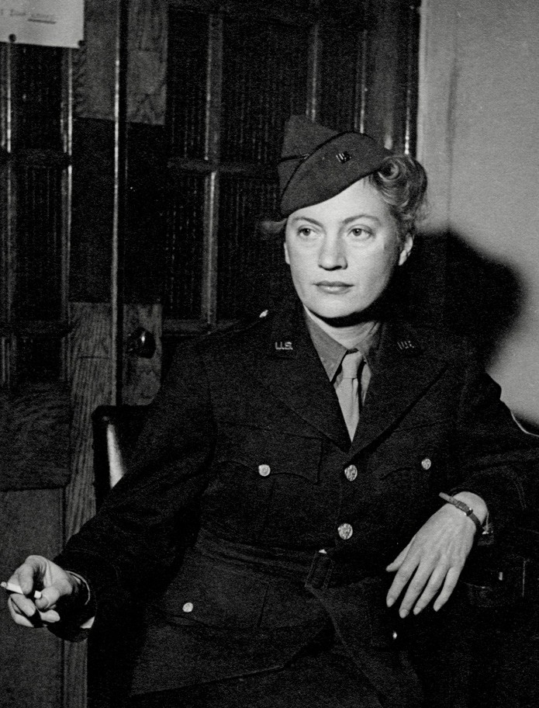
War correspondent uniform of jacket, skirt and hat
Knuckle duster
1943
Lee Miller Archives, East Sussex, England
Although not formally part of the armed forces, war correspondents were required to wear military uniform. On display is Miller’s formal Dress uniform. For her work in the field, she would have worn trousers and shirt, much like her male colleagues.
In 1943 Miller wrote: ‘Now I wear a soldier suit on account of that I’m war correspondent for Condé Nast press so you ought to see me all done up and very serious like in olive drab and flat heeled shoes and going round taking snaps of soldiers’.
Miller’s description belies the realities of a war correspondent, who risked their lives to tell the stories of war. The wearing of a uniform declared the dangers they faced and the respect they deserved.
Around the neck is one of two knuckle dusters in the collection at Farleys. This one is engraved with Miller’s signature and was worn as a pendant with evening wear.
[Photo caption]
Lee Miller, London, England, 1943
© Lee Miller Archives, East Sussex, England.
All Rights Reserved.

Scan here to find out more about this important outfit with Zenzie Tinker Conservation Studio and Lee Miller’s granddaughter Ami Bouhassane. | 

For an audio description of this garment scan QR code | 

