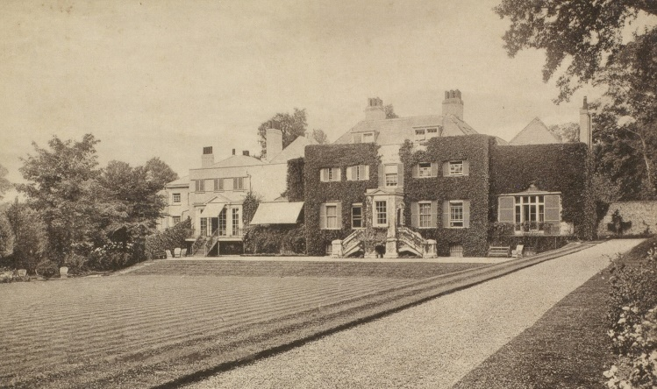
Preston Manor
Preston Park
Brighton
1897

Dear Class,
Let me introduce myself, my name is Benjamin Beesley and I am the Butler at Preston Manor in Brighton.

I work for Eleanor McDonald who owns the house. She lives with Lily, one of her four daughters, and some of the family dogs.

I am writing to inform you that you all have a place on the highly respected School for Servants course. You will learn how to clean a house, how to speak and act as servants and how to look after the family pets.

There are many daily chores to learn including:
-Polishing the silver
-Sweeping the floor
-Making the beds
-Brushing the clothes
-Folding the laundry

If you successfully pass the course, you will be a qualified Victorian servant.
We look forward to your arrival.

Yours sincerely,
Mr Benjamin Beesley, Butler

