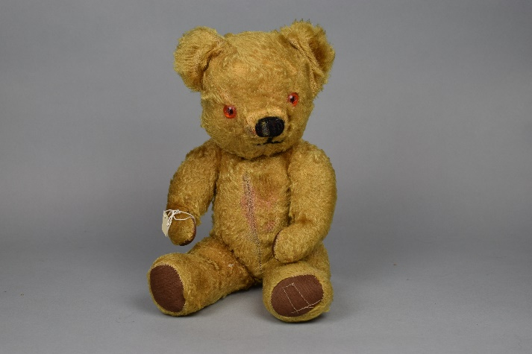
Hove Museum and Art Gallery
Hove

Dear Class
We have found some old toys here at Hove Museum. A long time ago the museum used to be a house where the Vallance family lived and the toys belonged to their children. The toys must have been left behind when they moved away. These toys are now very old, would you like to come and see them? We have been carefully looking after them at the museum.
There are toys for rich children and poor children, some toys that would have been bought for them and some the children would have made themselves. Can you tell which toys are old and new? Do you know which toys rich and poor children used to play with? Are they the same or different to the toys you play with today? Come and visit to tell us what you know and see all the toys we have.
We look forward to seeing you soon.

With best wishes,

Hove Museum staff

